[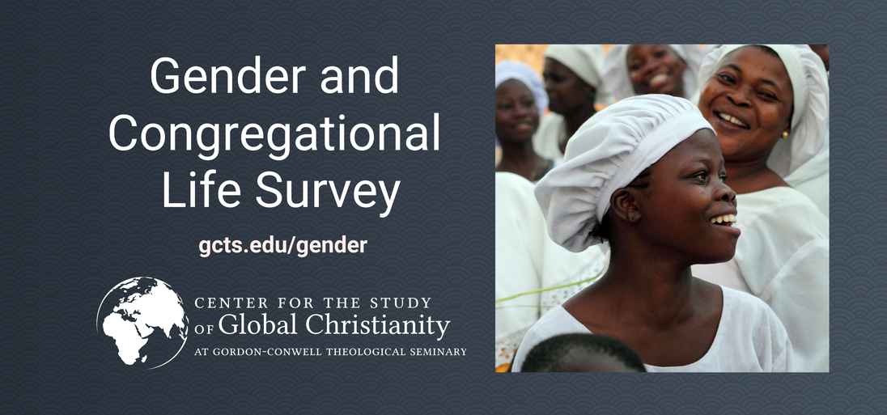](https://centerforglobalchristianity.typeform.com/to/JrHuaUuA)  
  
See inside for more details on this [survey](https://centerforglobalchristianity.typeform.com/to/JrHuaUuA).

|  |  |
| --- | --- |
| Journal of  African  Christian  Biography | **Vol. 6, No. 1 (Jan. 2021)**  **Focus**:  George Arthur Gatungu Gathuna (Kenya); Philip Kwabi and Daniel Saba (Gold Coast); Casely Essamuah (interview) |

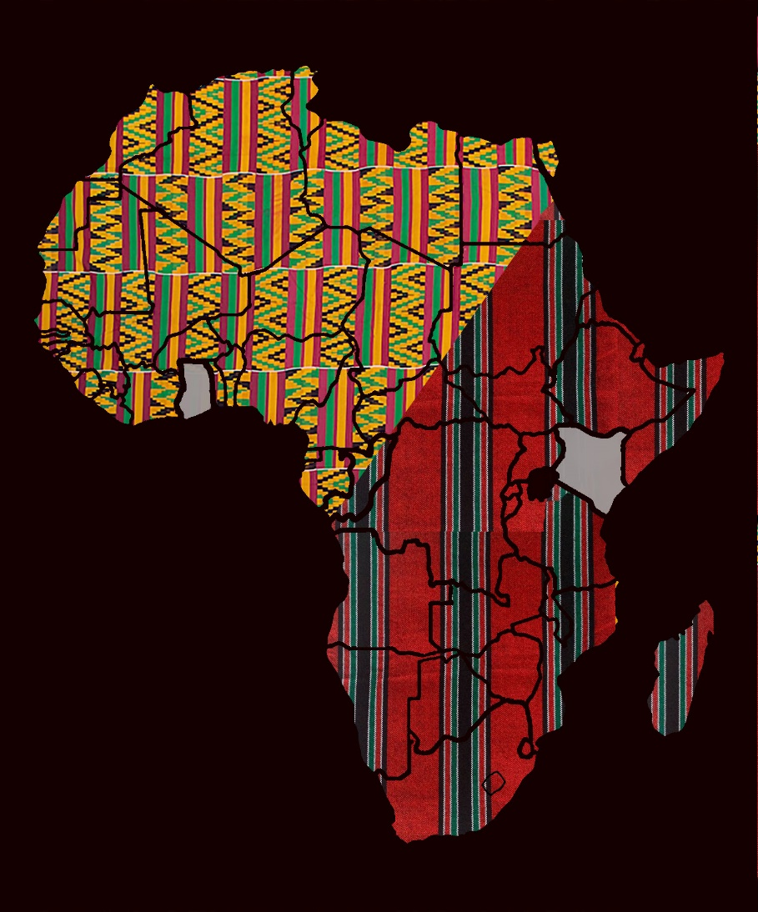  
  
A publication of the *Dictionary of African Christian Biography*